**Project Design Phase-II**

**Technology Stack (Architecture & Stack)**

|  |  |
| --- | --- |
| Date | 24 June 2025 |
| Team ID | LTVIP2025TMID20421 |
| Project Name | Streamlining Ticket Assignment For Efficient Support Operations |
| Mentor Name | Dr Shaik Salma Begum |
| Maximum Marks | 4 Marks |

**Technical Architecture:**

The Deliverable shall include the architectural diagram as below and the information as per the table1 & table 2

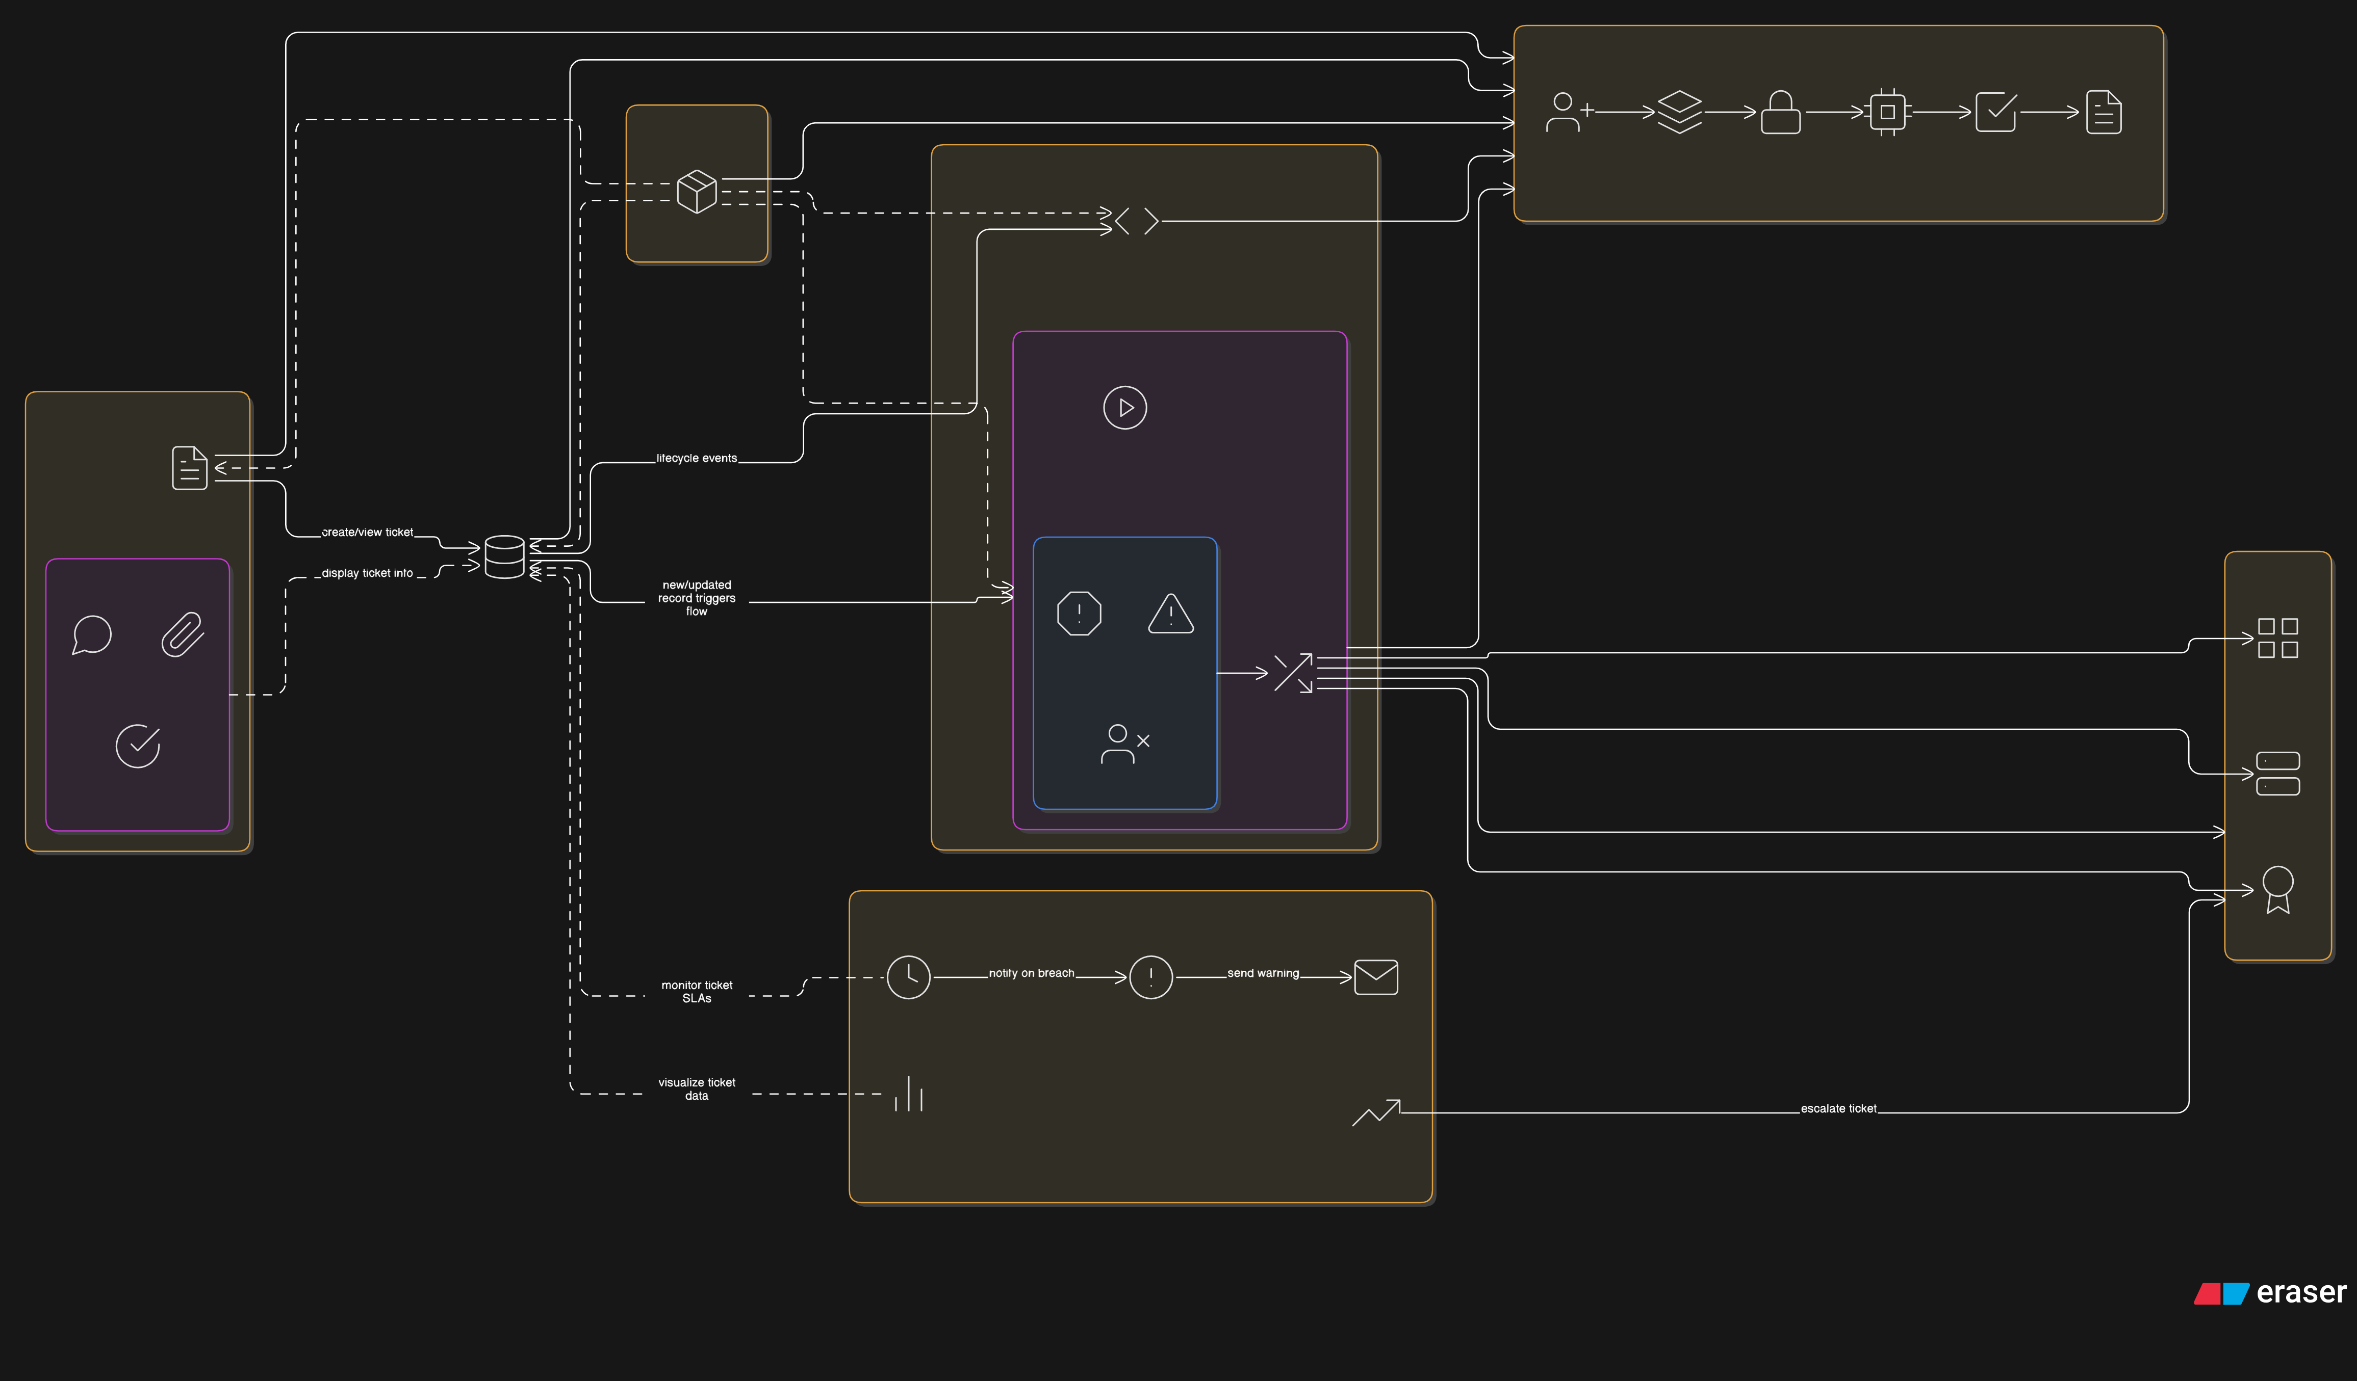

**Table-1 : Components & Technologies:**

|  |  |  |  |
| --- | --- | --- | --- |
| **S.No** | **Component** | **Description** | **Technology** |
| 1 | User Interface | Web-based ServiceNow forms for creating and viewing operations-related tickets | ServiceNow UI Framework (Form Designer, Lists) |
| 2 | Application Logic-1 | Dynamic form behavior (e.g., visibility based on issue selected) | ServiceNow Client Scripts, UI Policies (GlideForm API) |
| 3 | Application Logic-2 | Automated flow-based ticket assignment logic | ServiceNow Flow Designer |
| 4 | Application Logic-3 | Optional alerts to team via notifications | ServiceNow Notification Engine (for future use) |
| 5 | Database | Stores ticket data, issue types, and assignment rules | ServiceNow Custom Table: Operations Related (backed by MySQL) |
| 6 | External API-1 (Optional) | Integrations with other ITSM tools or external monitoring platforms (future scope) | ServiceNow REST API |
| 7 | Infrastructure (Cloud) | Secure hosting with redundancy and scaling | ServiceNow Cloud SaaS Platform |

**Table-2: Application Characteristics:**

|  |  |  |  |
| --- | --- | --- | --- |
| **S.No** | **Characteristic** | **Description** | **Technology** |
| 1 | Open-Source Frameworks | JavaScript used for both client and server logic | JavaScript (Glide APIs), AngularJS (optional for portals) |
| 2 | Security Implementations | Role-based access control (platform & certificate roles), encrypted connections | ServiceNow ACLs, HTTPS/TLS, Role-based Group Assignment |
| 3 | Scalable Architecture | Easily supports additional routing rules, issue types, and user roles | ServiceNow Cloud Architecture + Flow Designer |
| 4 | Availability | Highly available PDI/cloud instances ensure system uptime | ServiceNow SaaS Platform with built-in failover |
| 5 | Performance | Optimized flow execution and form loading | Caching layer + internal ServiceNow optimization + Akamai CDN |